**Project Planning Phase**

**Project Planning Template (Product Backlog, Sprint Planning, Stories, Story points)**

|  |  |
| --- | --- |
| Date | 30 June 2025 |
| Team ID | LTVIP2025TMID60614 |
| Project Name | Measuring the pulse of prosperity:an index of economic freedom analysis |
| Maximum Marks | 5 Marks |

**Product Backlog, Sprint Schedule, and Estimation (4 Marks)**

Use the below template to create product backlog and sprint schedule

| **Sprint** | **Functional Requirement (Epic)** | **User Story Number** | **User Story / Task** | **Story Points** | **Priority** | **Team Members** |
| --- | --- | --- | --- | --- | --- | --- |
| Sprint-1 | Registration | USN-1 | As a user, I can register for the application by entering my email, password, and confirming my password. | 2 | High |  |
| Sprint-1 |  | USN-2 | As a user, I will receive confirmation email once I have registered for the application | 1 | High |  |
| Sprint-2 |  | USN-3 | As a user, I can register for the application through Facebook | 2 | Low |  |
| Sprint-1 |  | USN-4 | As a user, I can register for the application through Gmail | 2 | Medium |  |
| Sprint-1 | Login | USN-5 | As a user, I can log into the application by entering email & password | 1 | High |  |
|  | Dashboard | USN-5 | As a team member ,I can created dashboard | 2 | high |  |
|  |  |  |  |  |  |  |
|  |  |  |  |  |  |  |

**Project Tracker, dashboard & storyt: (4 Marks)**

| **Sprint** | **Total Story Points** | **Duration** | **Sprint Start Date** | **Sprint End Date (Planned)** | **Story Points Completed (as on Planned End Date)** | **Sprint Release Date (Actual)** |
| --- | --- | --- | --- | --- | --- | --- |
| Sprint-1 | 20 | 2 Days | 21 june 2025 | 23 june 2025 | 20 | 23 june 2025 |
| Sprint-2 | 20 | 2 Days | 24 june 2025 | 26 june 2025 |  |  |
| Sprint-3 | 20 | 2 Days | 27 june 2025 | 28 june 2025 |  |  |
| Sprint-4 | 20 | 2 Days | 29 june 2025 | 31 june 2025 |  |  |
|  |  |  |  |  |  |  |
|  |  |  |  |  |  |  |
|  |  |  |  |  |  |  |
|  |  |  |  |  |  |  |

**Dash Board**

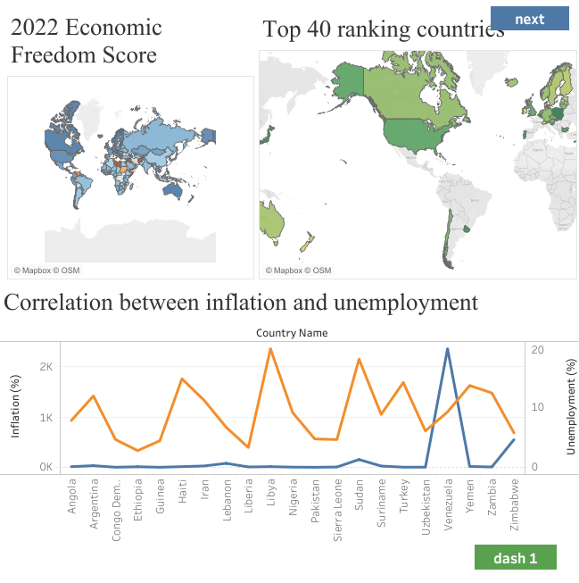**"C:\Users\chara\Downloads\Dashboard 1.png"**

**Story:**

**"C:\Users\chara\Downloads\Dashboard 1.png"**

